Proposal: Extended Salesforce Integration with Custom Object Field Mapping
Client: GenRocket
Prepared by: MindMatrix Integration Team

1. Overview
MindMatrix (MM) has an existing integration with Salesforce (SFDC), where Accounts and Contacts marked with specific flags are provisioned as Organizations and Users respectively in MM.
Provisioning is currently based on:
- MindMatrix__IsPartner__c (custom checkbox field on Account)
- MindMatrix__PortalAccess__c (custom checkbox field on Contact)
When both fields are TRUE, MM pulls the corresponding records to create a linked Organization and User in its database using a granular field mapping model.

2. New Enhancement: Custom Lookup Object Field Mapping
We have extended the provisioning model to allow field-level data mapping from a custom lookup object attached to the Account or Contact.

Example Scenario:
- Account: VTech Solutions
- Custom Lookup Object: VTech Custom (instance of MindMatrix__Account__c)
- Custom Lookup Field on Account: CustomAccount
If VTech Solutions has MindMatrix__IsPartner__c = TRUE, we will:
- Pull VTech Solutions as the primary account.
- Use its linked VTech Custom custom object to map organization field values in MM.

Result:
An Organization is created in MM, but with field values sourced from the linked custom object (VTech Custom), not directly from the Account.

Screenshot Reference:
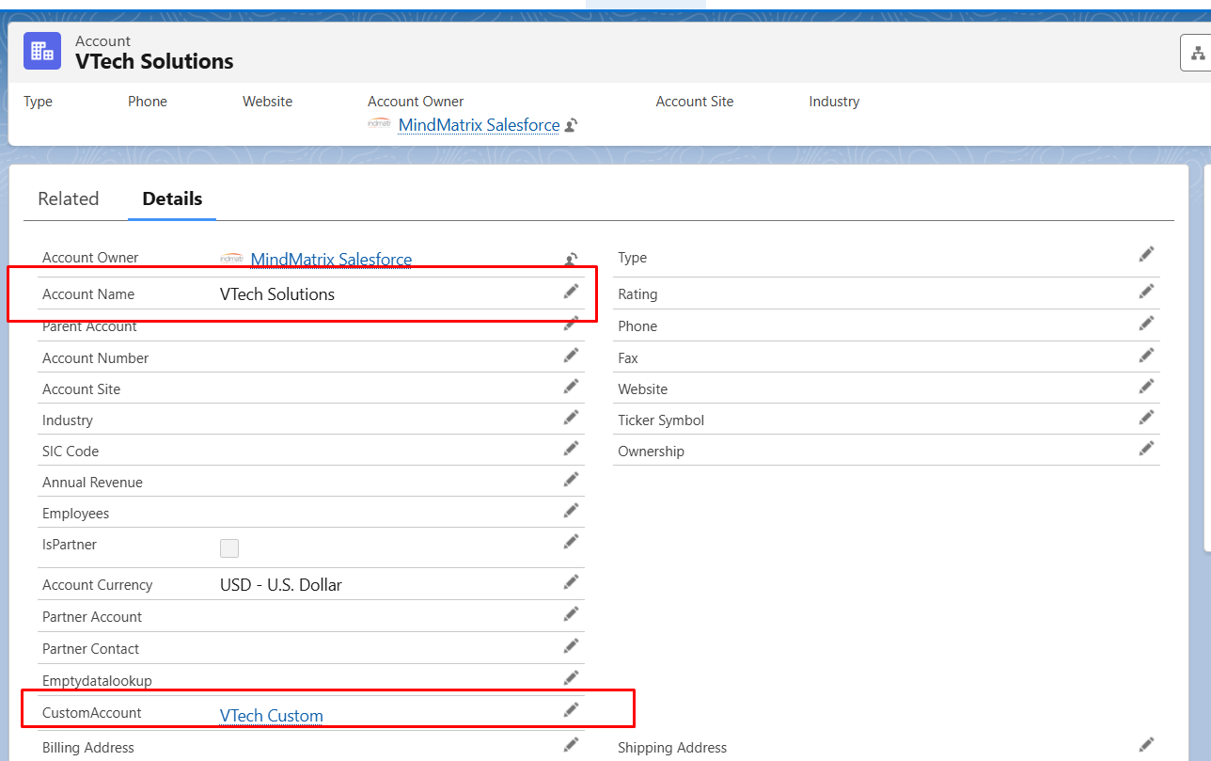
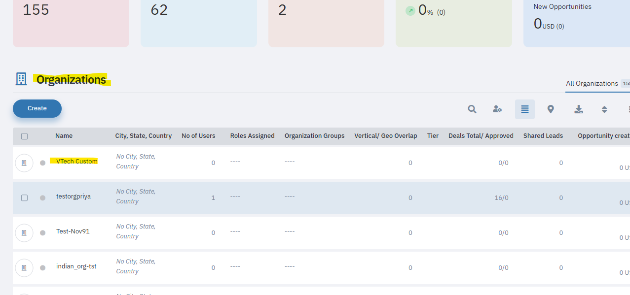

3. Field Mapping Logic
The mapping engine supports deep mapping via lookup references using dot notation:
- CustomAccount.name → maps to Organization Name
- CustomAccount.phone → maps to Organization Telephone
This allows dynamic mapping of:
- Custom fields
- Related object fields
- Nested references via standard or custom relationships

Screenshot Reference:

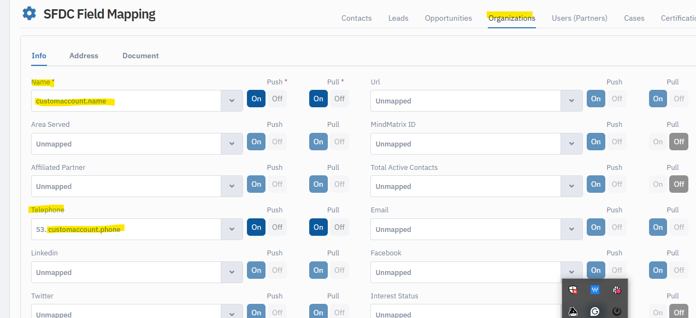

4. Filtering Criteria
Records are filtered based on:
- Accounts where MindMatrix__IsPartner__c = TRUE
- Contacts where MindMatrix__PortalAccess__c = TRUE
Only those Account and Contact pairs that meet the criteria are eligible for sync.

5. Development Status & Roadmap
- Currently Supported:
The custom object field mapping is currently supported only for pull operations, i.e., when MM pulls data from SFDC to provision Organizations and Users.
- Push Support Under Development:
The ability to push updates from MM to SFDC custom object fields is actively under development.
- Testing Timeline:
  - The push logic will be available in the sandbox environment within 2 weeks for internal testing.
  - After successful testing, it will take approximately 1 additional week to roll it out to production.

6. Benefits of This Extension
- Enables organizations to maintain clean, abstracted data in SFDC.
- Provides more flexibility by allowing:
  - Mapping from dedicated integration-friendly objects.
  - Future extensibility to other custom lookup objects.
- Reduces dependency on core Account/Contact fields for integration logic.
- Future bidirectional sync will allow MM to push updates back to custom objects, ensuring data consistency.

7. Conclusion
This enhancement significantly increases the flexibility and scalability of the MM-SFDC integration, enabling GenRocket to maintain rich partner data in structured custom objects while ensuring accurate and granular provisioning into MindMatrix. The roadmap for push integration will further enhance this capability in the coming weeks.

